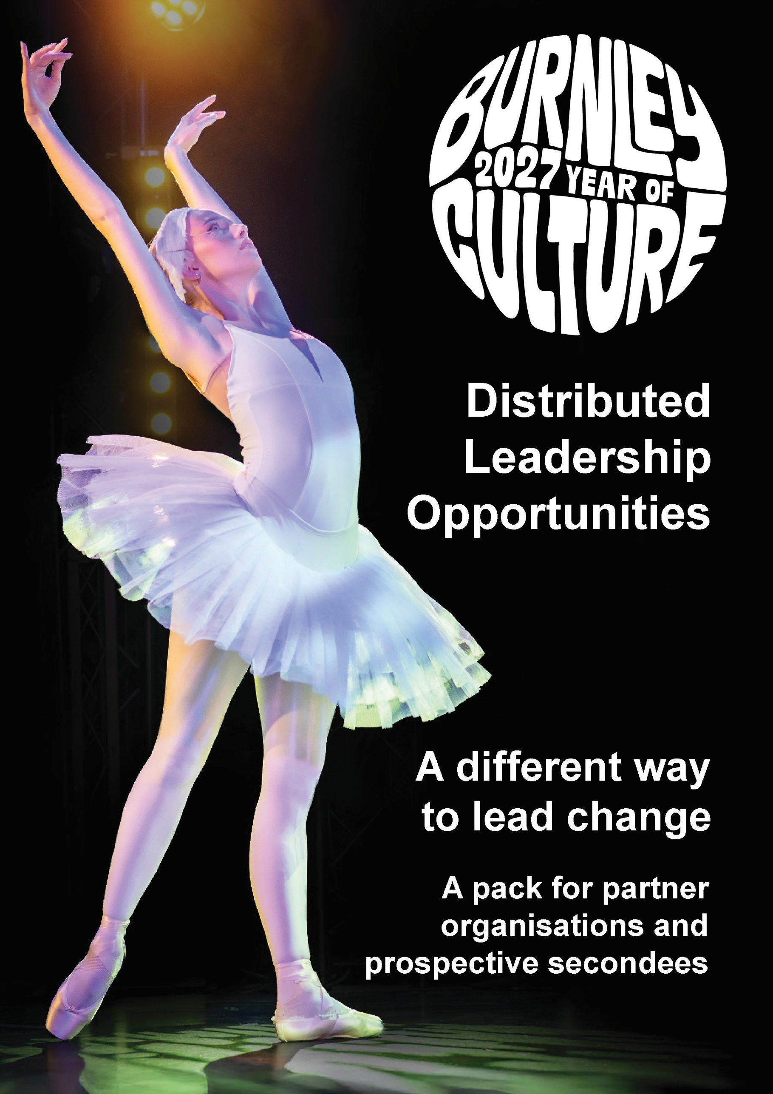

Help Shape Burnley 2027
Secondment opportunities enabling people from local organisations to bring their expertise into the partnership, develop networks and skills while remaining employed by their host organisation.
About Burnley 2027 Year of Culture
Burnley 2027 is a year-long celebration of the people, places, creativity and stories that make our borough unique and an opportunity to use culture as a catalyst for lasting change.
Throughout 2027, an ambitious programme of events, performances, commissions, festivals and community-led activity will take place across Burnley and Padiham, bringing culture into our venues, neighbourhoods and public spaces and creating opportunities for people to experience, participate in and make culture.
However, Burnley 2027 is about much more than one year of activity. It is an opportunity to create the infrastructure that supports sustainable long-term change, build pride in place, change perceptions of place, widen participation, support local artists and creative talent, create opportunities for young people, strengthen our cultural and creative sector and forge new connections between culture, communities, education, business, health and the wider life of the borough.
Developed through the Culture Burnley partnership and led by Burnley Leisure & Culture, Burnley 2027 is bringing organisations and communities together around a shared ambition: to build skills, relationships and confidence to create a stronger future for our borough.
How the distributed leadership model works
To deliver Burnley 2027, Burnley Leisure and Culture’s approach is designed to distribute leadership across the borough rather than locate all responsibility within one organisation. This model is based on the successful Together an Active Future (TaAF) programme operated across Pennine Lancashire using a place-based and whole systems approach as the foundation for enabling sustainable change in approaches to physical activity.
Different organisations can be funded to lead specific aspects of the work while participants maintain their existing roles. The intention is to broaden skills, strengthen partnerships, retain knowledge locally and support sustainable cultural development by investing in who is already here, rather than creating a new team that disappears when funding ends.
The opportunity for participants
• Develop skills, experience and networks.
• Bring existing knowledge and expertise into a new operating model.
• Try new things and work in new ways.
• Play a key role in shaping cultural development across Burnley.
• Share learning between partners and your existing workplace.

The opportunity for host organisations
• Access new skills and experience through the seconded employee.
• Build stronger connections with partners and collaborators across the borough.
• Support more coordinated strategic partnership working and pooling of resources.
• Receive payment for the seconded service, which may be used to backfill staff time or otherwise invest in operations.
Core working arrangement
• Appointments will be based on the capability and experience of the named person to deliver the role with minimal supervision; nomination by an organisation does not guarantee appointment.
• Roles are not traineeships - suitably qualified and experienced team members are required.
• Team members will work alongside Burnley Leisure & Culture’s Head of Culture, who will provide oversight and act as lead contact.
• The participant remains an employee of the host organisation and is contracted out to Burnley Leisure & Culture.
• Team members are expected to be engaged up to an average of one day per week, from local partner organisations while retaining their existing role.
• In line with funding levels available for each opportunity, at contract stage, an agreement will be made of the actual number of days to be delivered, and team members will be required to log the hours for reporting purposes.
What Burnley Leisure and Culture will provide
• Clear roles and responsibilities, structure, direction and support.
• Workloads proportionate to the paid time commitment and flexibility of days/times wherever possible.
• Opportunities to share learning across the team and wider partnership.
• Regular communication, progress monitoring, problem-solving support and connections to wider networks.
• Supporting funds for the delivery of activity - note that advertised values relate to time only, further funds for the delivery of outputs will be included in contracts where available.
What participants will be expected to bring
• Commitment to Burnley’s Cultural Framework and the shared outcomes of Burnley 2027.
• Professional representation of Culture Burnley and Burnley 2027.
• Delivery that meaningfully contributes to agreed Year of Culture ambitions.
• Reliability, flexibility, active participation in team meetings and open communication.
• A collaborative mindset: sharing information, expertise, progress, networks and learning.
• Commitment to deliver outputs to expected standards and by agreed deadlines.
What host organisations will be expected to provide
• Protected contracted time and a proportionate adjustment to the participant’s existing workload.
• Support and guidance, plus opportunities for learning to flow back into the host organisation.
• Regular communication with Burnley Leisure and Culture and early notice of changes that could affect the secondment.
• Relevant connections, networks and wider expertise that can strengthen the partnership.
Important terms
Contracts are expected to be renewed annually by mutual agreement. Any party may terminate with at least one month’s notice, subject to the detailed contract terms. Burnley Leisure and Culture may adjust priorities and team composition as the programme develops.
Expression of interest process:
Contact Charlotte Steels with an expression of interest letter outlining why you or your organisation are suitable for the opportunity and attach CV(s) of any relevant team members that would be involved in delivery. Please clearly state whether you are applying for one opportunity or a package of opportunities.
Closing date: 6 September 2026
Contact for informal enquiries: Charlotte Steels csteels@blcgroup.co.uk / 07866 855470


Youth Placements Lead

Contract Value: £20,000 up to 24 months
Create opportunities for young people to gain meaningful experiences and build their futures.
You’ll lead on the facilitation of the Burnley Creative Futures programme, connecting employers, education and skills providers and young people to develop and coordinate high-quality placements including approximately 8 paid apprenticeship / internship placements. From identifying opportunities and supporting recruitment to connecting placements with learning, mentoring and development, you’ll help make sure the programme provides a valuable and consistent experience for participants and hosts.
Time: 1 day per week
Who can apply: Individuals, organisations, freelancers
Responsibilities
• Negotiation and allocation of programme budget in conjunction with BLC’s Head of Culture.
• Liaise with partners to identify placement opportunities and support candidate recruitment.
• Coordinate education and skills providers around learning and skills-sharing support as appropriate.
• Support host organisations through mentoring as needed, to ensure experiences are consistent and high-quality.
• Work with relevant leads to connect placements to career pathways and progression.
• Run promotional roadshows and advertise opportunities.
• Coordinate masterclasses, mentoring, careers guidance and progression support / signposting for the young people as needed.

Who this may suit
You are likely to bring experience of placements, employability, recruitment, workforce development, education partnerships or programme coordination, with strong relationship management and attention to participant experience.

